### PCS AUTOMATION

Developed By

Name: Sanjeevi.S Reg. No: S210030100022

# NIIT

### PCS AUTOMATION

Batch Code : S210167

Start Date : 12.11.2020

End Date : 12.12.2020

Name of the Coordinator : LOPAMUDRA BERA

Name of the Developer : SANJEEVI S

Date of Submission : 12.12.2020

**NIIT**

###### **CERTIFICATE**

This is to certify that this report, titled **PCS AUTOMATION** embodies the original work done by **Mr.S.SANJEEVI**, in partial fullfillment of his course requirement at NIIT.

**ACKNOWLEDGEMENT**

Any accomplishment requires work of many people.I am gratefull to our teacher Ms.LOPAMUDRA BERA who guided us to complete this project and my special thanks to my batch members who helped me in completing this project.Learning new things kept me interested in doing this project.Finally i would like to thank my family who supported me throughout the project.

**ABSTRACT**

This project manages the entire process of allocating project to existing employees as per his/her skillset working in that company

This project also provides single window system to Employee,HR and Project Manager of a company to cater the skill specific requirements emerging in Projects.

**Coordinator** : LOPAMUDRA BERA

### CONFIGURATION

**Hardware:**

* Laptop -Pentium
* 4 Ram,500GB Hard Disk

**Operating System:**

* Windows 10 x64

**Software:**

* Eclipse,MySql,JRE,MS WORD,MS EXCEL.

### TABLE OF CONTENTS

Chapter 1- Introduction

1.0 Aim

1.1 Objectives

1.2 Case Study

Chapter 2- Project Requirement Specification

2.0 Literature Research

2.1 Statement of Requirements

2.2 Vision Document

2.3 Project Life Cycle Model

Chapter 3- Project Analysis

3.0 Project Plan

3.1 System Architecture

3.2 Business Process Model

3.3Software Requirement Specification

3.4High Level Use Case Diagrams

Chapter 4- Project Design

4.0 Low Level Use Case Diagrams

4.1 User Interface Design

4.2 Systems Input and Output Design

4.3 Database Structure

4.4 Entity Relationship Diagram

4.5 Data Model

4.6 Class Diagrams

4.7 Activity Diagrams

4.8 Sequence Diagrams

4.9 User-centered Interface Designs

4.10 Personas

4.11 Paper Prototypes

4.12 Web Interfaces

4.13 Change Request Form

Chapter 5- Project Implementation

5.0 Acceptance Plan

5.1 System Support Plan

Chapter 6- Project Testing

6.0 Test Plan

6.1 Test Cases

Chapter 7- Project Deployment

7.0 Training Plan

7.1 Component and Deployment Diagrams

7.2 Deployment Plan

7.3 Maintenance Request

7.4 Service Level Agreement

7.5 Maintenance Plan

Challenges

Observations

References

Appendix

**AIM:**

* To create an mapping application to store the details of the employees in the company and operates through the online portal.

**OBJECTIVES:**

* This project manages the registration of all the employees in the company through the portal which can be viewed by the HR and th MANAGER.Previously they were manually stored now they are automated.

**CASE STUDY:**

Professionet Consultancy Services (PCS) is a business consultancy that has established itself as a renowned service provider of a wide range of business services to its clients.

PCS offers an offline platform for their employees to share their profiles to initiate internal job posting process with the expert Human Resources consultants.

There are over 22,000 new and 50,000 experienced PCS professionals providing their services to 150 clients aligned with the consultancy. The consultancy needs to maintain the information of every PCS employee focusing on their industry vertical. All PCS employees are registered with PCS and are given a unique identification number. Profile validation is done by the HR experts and requirements are full filled by mapping skills and requirements manually.

The Consultancy wants to introduce automation in their Internal Job Posting (IJP) selection and recruitment process so that the potential PCS employees and HR department have an online platform based on a skill map engine to connect directly with each other and aid their job search within the company. HR and PM can also post their jobs and refine their search by using keywords that matches the profiles.

**LITERATURE RESARCH**

**INTRODUCTION:**

To automate the process of registration which will help the HR to map the employees in the company and also the job seekers in the industry and offer them the right job.This process will help the HR to finish the work earlier than taking longer time.

### STATEMENT OF REQUIREMENTS

**PROJECT OBJECTIVES**

|  |  |
| --- | --- |
| **Title** | PCS Automation Ltd |
| **Subtitle** | Employee Management System |
| **Author** | Sanjeevi.S |
| **Author’s E-mail** | 2sanjeevi2@gmail.com |
| **Author’s Phone** | 9094974430 |
| **Description** | Automated Consultancy Service |
| **Version** | 1 |

**About Your Company:**

Professionet Consultancy Services(PCS) is a business consultancy which provides a wide range of business services to clients and oppurtunities to job seekers.

**Need for Process Automation:**

* Adds consistency to recruitment.
* Increases the efficiency of HR team.
* Saves time through automation.
* Guides organizations to find the right talent

**Software Requirements**

* JRE
* ECLIPSE
* MYSQL
* MS WORD
* MS EXCEL

**PROJECT PLAN**

|  |  |  |  |  |  |
| --- | --- | --- | --- | --- | --- |
| **Project phase** | **Week 1** | **Week 2** | **Week 3** | **Week 4** | **Week 5** |
| **Requirement**  **Gathering** |  |  |  |  |  |
| **Low Level Design** |  |  |  |  |  |
| **Code Development** |  |  |  |  |  |
| **Testing** |  |  |  |  |  |
| **Rool Out** |  |  |  |  |  |

### PROJECT LIFE CYCLE MODEL

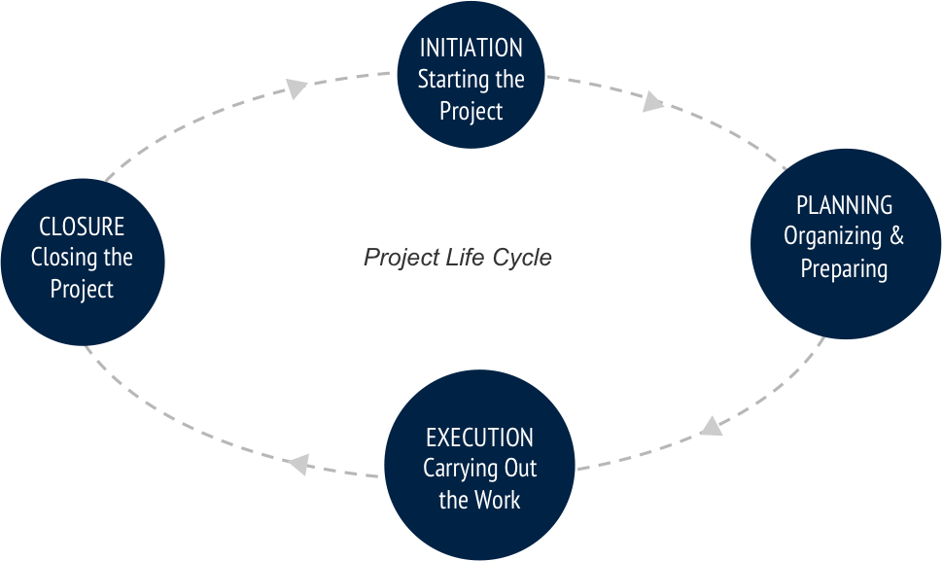

**The Initiation Phase:**

The initiation phase aims to define and authorize the project.

**The Planning Phase:**

 The purpose of this phase is to lay down a detailed strategy of how the project has to be performed and how to make it a success.

**The Execution Phase:**

 In this phase, the decisions and activities defined during the planning phase are implemented.

**The Termination Phase:**

  This is the last phase of any project, and it marks the official closure of the project.

### SYSTEM ARCHITECTURE

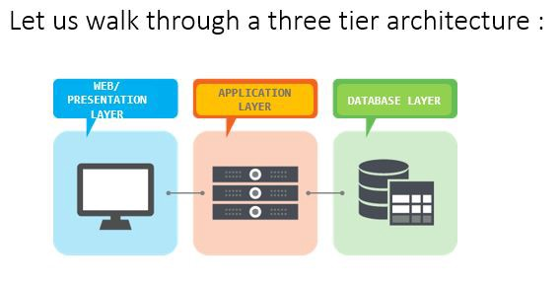

1. Tier Architecture

* **Presentation Tier:**
* The presentation tier is the front end layer in the 3-tier system and consists of the user interface. This user interface is often a graphical one accessible through a web browser or web-based application and which displays content and information useful to an end user. This tier is often built on web technologies such as HTML5, JavaScript, CSS, or through other popular web development frameworks, and communicates with others layers through API calls.
* **Application Tier:**
* The application tier contains the functional business logic which drives an application’s core capabilities. It’s often written in Java, .NET, C#, Python, C++, etc.
* **DataBase Tier:**
* The data tier comprises of the database/data storage system and data access layer. Examples of such systems are MySQL, Oracle, PostgreSQL, Microsoft SQL Server, MongoDB, etc. Data is accessed by the application layer via API calls.

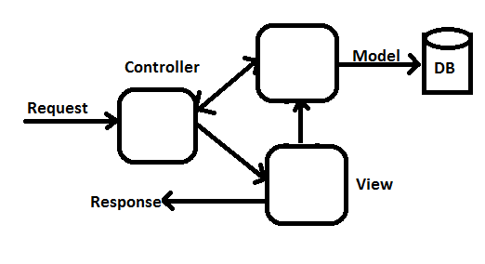

### BUSINESS PROCESS MODEL

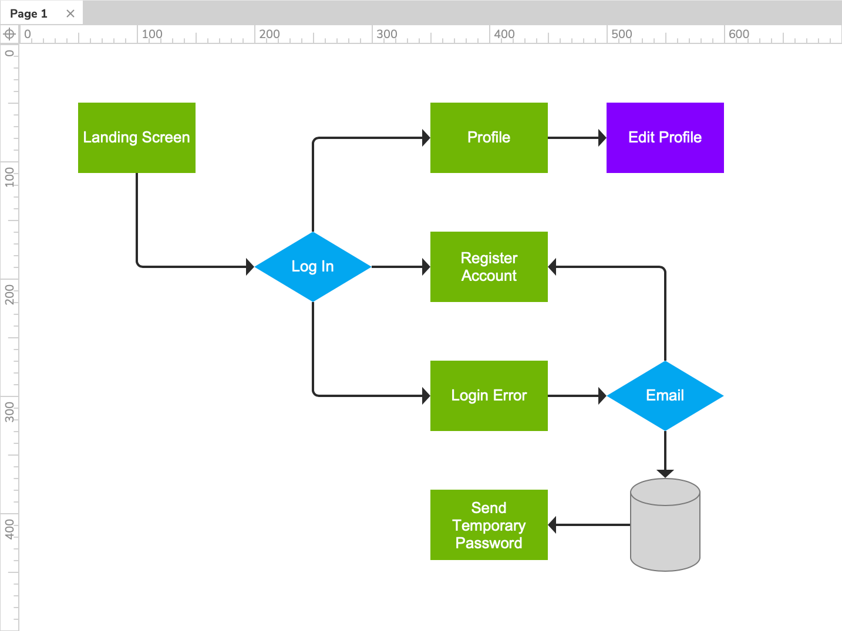

**LOW LEVEL DESIGN**

**ViewProfile**

ApplyJob

UpdateProfile

**EMP HOME**

**LOGOUT**

**UpdateSkill**

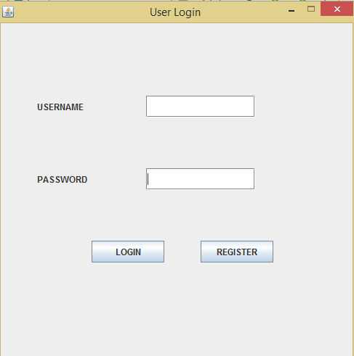

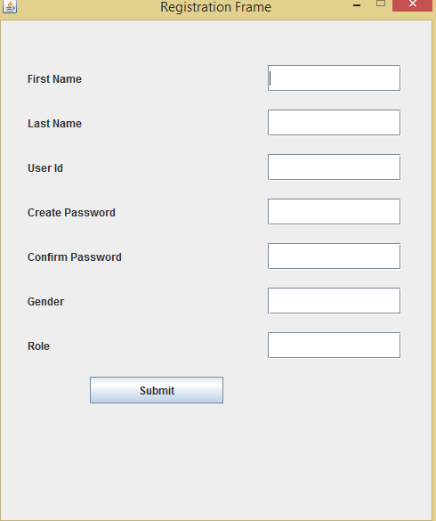

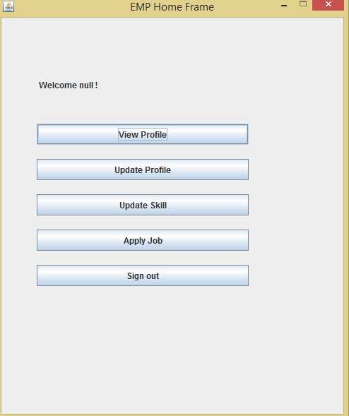

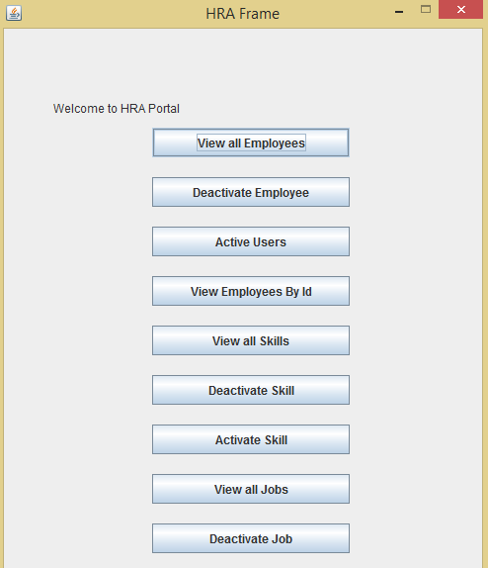

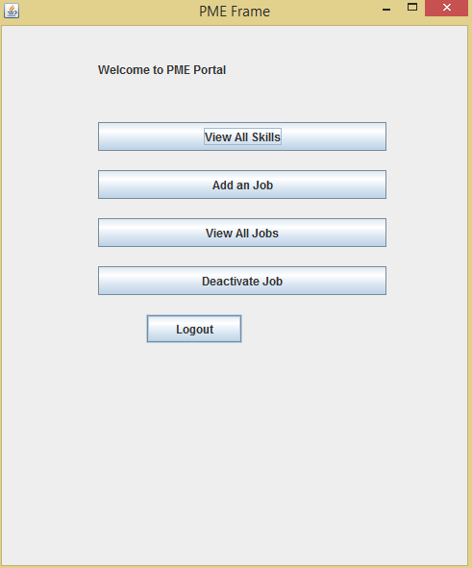

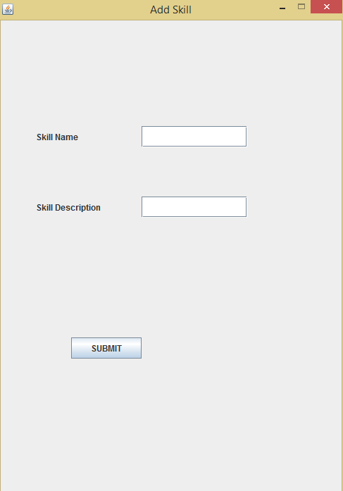

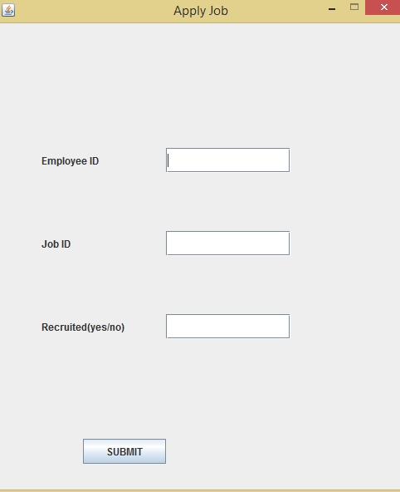

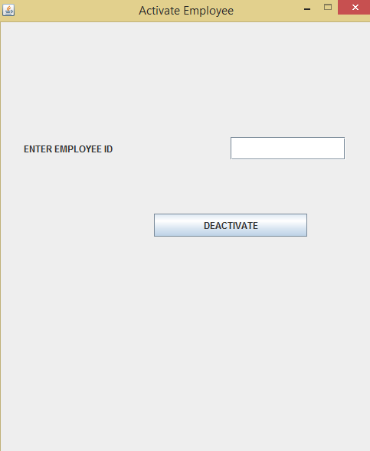

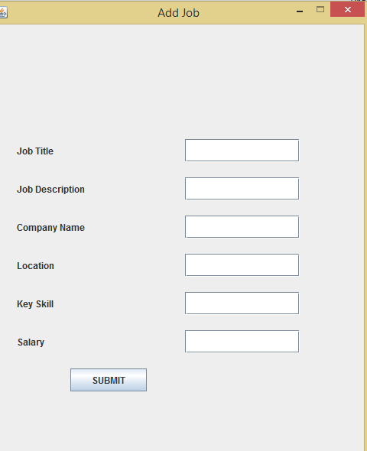

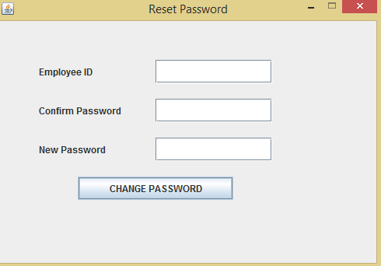

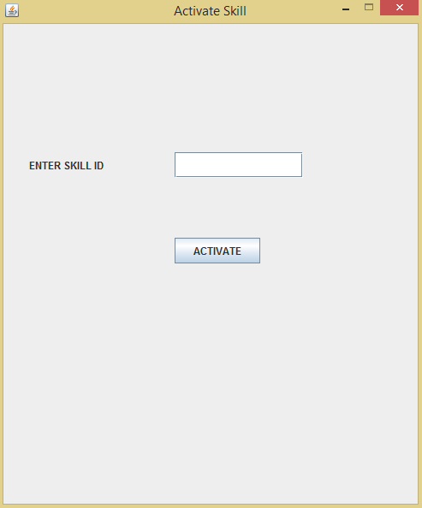

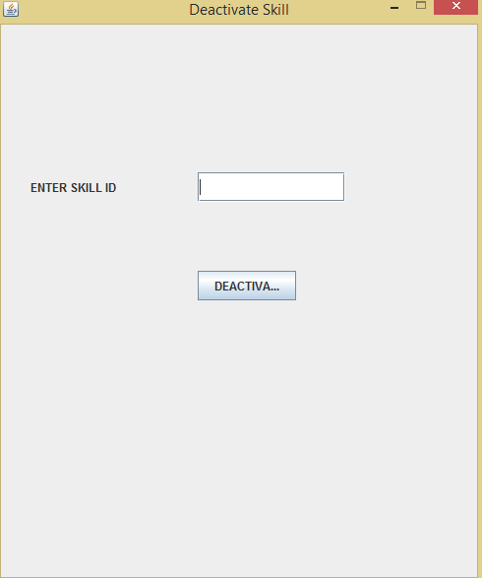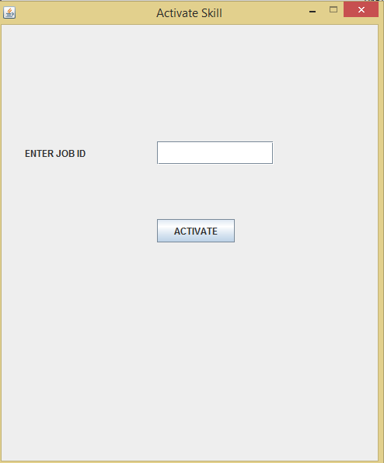

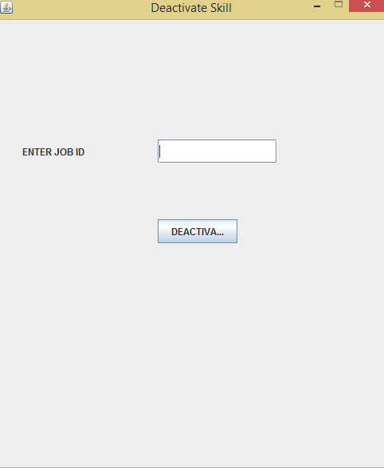

DATABASE

create database pcsdb;

use pcsdb;

create table Employee (

empID int primary Key auto_increment,

FirstName varchar(30) not null,

LastName varchar(30) not null,

UserId varchar(30) not null,

Password varchar(20) not null,

Role varchar(3employeeemployee) not null,

Gender varchar(10) not null,

Active varchar(10) not null

);

select *from Employee;

create table Skill (

SkillId int primary key auto_increment,

SkillName varchar(30) not null,

SkillDescription varchar(500) not null,

Active varchar(10) not null

) ;

select * from Skill;

create table Job (

JobId int primary key auto_increment,

JobTitle VARCHAR(40) not null,

JobDescription VARCHAR(500) not null,

CompanyName VARCHAR(50) not null,

Location VARCHAR(30) null,

KeySkill VARCHAR(50) not null,

Salary int not null,

Active varchar(20) not null

);

select * from Job;

create table EmpSkill (

ESId int primary key auto_increment,

EmployeeId int not null,

SkillId int not null,

ExpYear int not null

);

select * from EmpSkill;

create table EmpJob (

EJId int primary key auto_increment,

EmployeeId int not null,

JobId int not null,

Recruited varchar(50) not null

);

select * from EmpJob;